NOTES
A/B Testing
A/B testing is a way to compare two versions of something to determine which version performs better.
The A/B test analyzes a small group of users drawn from the total population of all users. In stats, we call this smaller group the sample. The sample is a subset of the larger population. You can use data from a sample to make inferences or draw conclusions about the entire population. Data professionals use inferential statistics to make inferences about a dataset based on a sample of the data.
Sampling, the process of selecting a subset of data from a population, is a critical part of an A/B test. Before you conduct the test, you need to decide on the sample size or the number of users in the test. Choosing the right sample size helps you get valid test results and avoid statistical errors.
Like any statistical test, an A/B test can't predict user behavior with 100 percent certainty. What stats can do is construct a confidence interval or a range of values that describes the uncertainty or surrounding an estimate. Knowing how to construct and interpret a confidence interval helps you make informed decisions about all users based on your test sample. Using stats, you can quantify the uncertainty of your A/B test and share this information with stakeholders to help them interpret the results.

Descriptive Statistics
Descriptive statistics describe or summarize the main features of a dataset. Descriptive stats are very useful because they let you quickly understand a large amount of data.
Let’s say you had data on the heights of 10 million people. You probably don't want to scan 10 million rows of data to analyze it for your report. Even if you did, it would be difficult to interpret the data. However, if you summarize the data, you can instantly make it meaningful. Finding the mean or average height gives you useful knowledge about the data plus reading a summary is much better than staring at millions of rows of data.
Two common forms of descriptive statistics
- visuals like graphs and tables
- summary stats: let you summarize your data using a single number (ex: mean or average)
There are two main types of summary stats, measures of central tendency and measures of dispersion: measures of central tendency like(mean) and measures of dispersion (standard deviation), let you describe the spread of your dataset or the amount of variation in your data points.
Stats like mean and standard deviation are used to describe and summarize data but to draw conclusions and make predictions based on data they use inferential statistics.
Inferential statistics
Inferential statistics allow data professionals to make inferences about a dataset based on a sample of the data. A sample is a smaller group or subset of any of these populations and it should be representative of your population. Samples might be residents, planets, or coin flip outcomes.
A parameter is a characteristic of a population.
A statistic is a characteristic of a sample.
For example, the average height of the entire population of giraffes is a parameter. The average height of a random sample of 100 giraffes is a statistic. We use the known value of a sample statistic, the average of 100 giraffes, to estimate the unknown value of a population parameter.
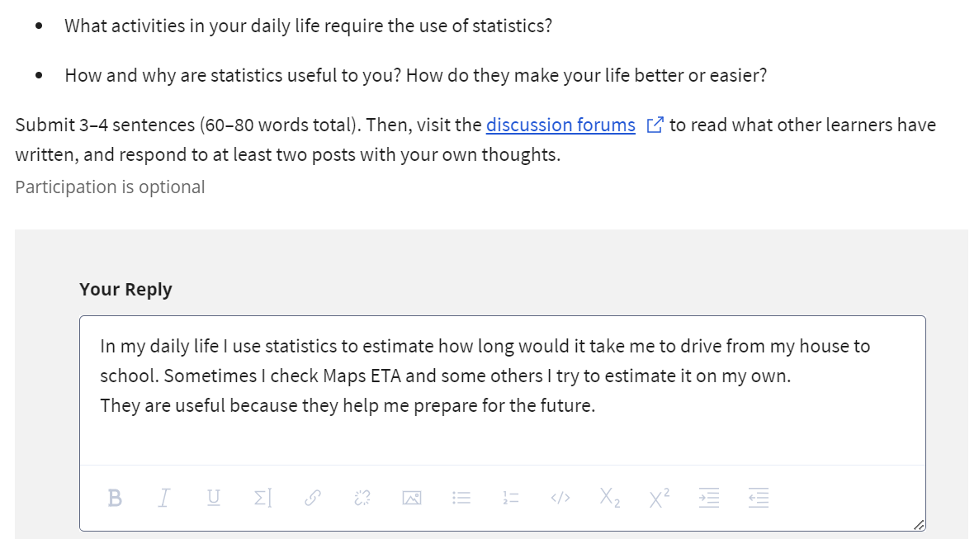

Measures of central tendency
- Mean: average value of the data set (media)
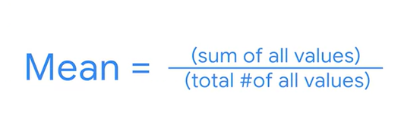
- Median (mediana):
Odd number :average of the two middle values
Even: middle value

Outlier is a value that differs greatly from the rest of the data
If outliers, use median
If not, use mean

- Mode: most frequently occurring value in a dataset.
Ex: 1,2,3,4,5 no mode
Ex: 1,2,3,3,4,5 one mode (3)
Ex: 1,2,2,4,4 two modes
Useful when working with categorical data bc it shows you what category occurs most frequently.

Measures of dispersion
Range: difference between the largest and smallest value in the dataset
Standard deviation: measures who spread out your values are from the mean of your dataset. It calculates the typical distance of a data point from the mean.
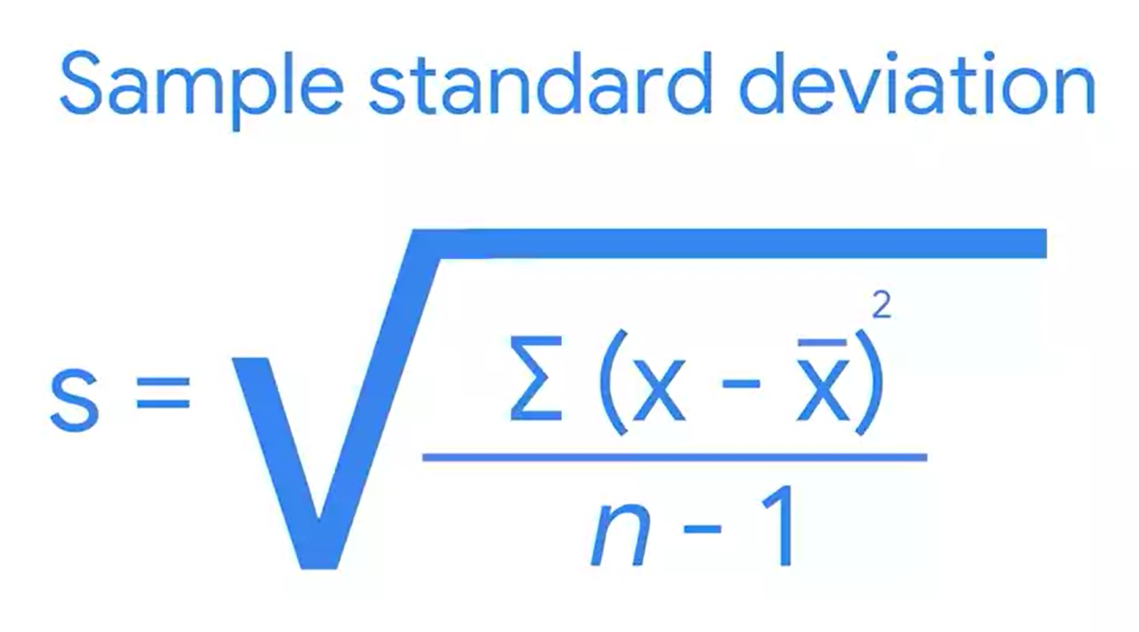(x-bar is the mean)
Variance: the average of the squared difference of each data point from the mean. Basically, it's the square of the standard deviation.
Measures of position
help you determine the position of a value in relation to other values in a dataset.
A percentile is the value below which a percentage data falls.
They show the relative position or rank of a particular value in a dataset.
Note: Percentiles and percentages are distinct concepts. For example, say you score 90/100, or 90%, on a test. This doesn’t necessarily mean your score of 90% is in the 90th percentile. Percentile depends on the relative performance of all test takers. If half of all test takers score above 90%, then a score of 90% will be in the 50th percentile.

You can use quartiles to get a general understanding of the relative position of values. A quartile divides the values in a dataset into four equal parts.
Three quartiles divide the data into four quarters. Quartiles let you compare values relative to the four quarters of data. Each quarter includes 25% of the values in your dataset.
- The first quartile, Q1, is the middle value in the first half of the dataset. Q1 refers to the 25th percentile. 25% of the values in the entire dataset are below Q1, and 75% are above it.
- The second quartile, Q2, is the median of the dataset. Q2 refers to the 50th percentile. 50% of the values in the entire dataset are below Q2, and 50% are above it.
- The third quartile, Q3, is the middle value in the second half of the dataset. Q3 refers to the 75th percentile. 75% of the values in the entire dataset are below Q3, and 25% are above it.
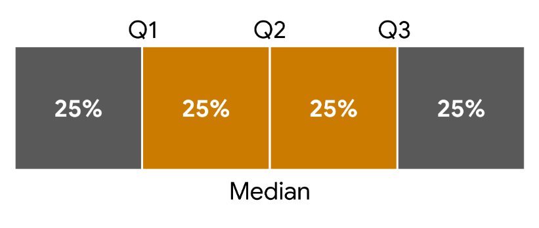

The middle 50% of your data is called the interquartile range, or IQR. The interquartile range is the distance between the first quartile (Q1) and the third quartile (Q3). This is the same as the distance between the 25th and 75th percentiles. IQR is useful for determining the relative position of your data values. For instance, data values outside the interval Q1 - (1.5 * IQR) and Q3 + (1.5 * IQR) are often considered outliers.
Note: Technically, IQR is a measure of dispersion because it measures the spread of the middle half or middle 50% of your data (between Q1 and Q3). IQR is less sensitive to outliers than the range because it doesn’t include the more extreme values in your dataset.
IQR = Q3 - Q1.
Five number summary
You can summarize the major divisions in your dataset with the five number summary. The five numbers include:
- The minimum
- The first quartile (Q1)
- The median, or second quartile (Q2)
- The third quartile (Q3)
- The maximum
It is useful because it gives you an overall idea of the distribution of your data, from the extreme values to the center. You can visualize it with a box plot.
The box part of the box plot goes from Q1 to Q3. The vertical line in the middle of the box is the median (Q2). The horizontal lines on each side of the box, known as whiskers, go from Q1 to the minimum, and from Q3 to the maximum.
You can find the values on the box plot and determine the interquartile range (IQR). The IQR is the length of the box, or the distance from Q1 to Q3.
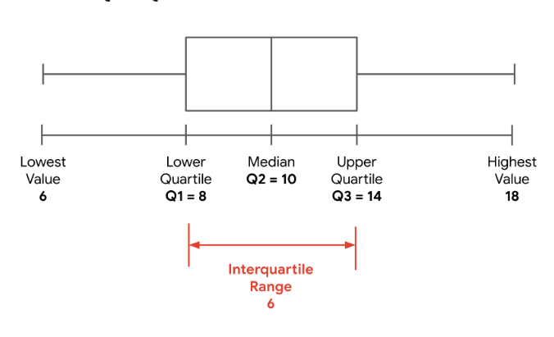

Quizzes results



